Explore Weather Trends
Damascus City

In this project, I have analyzed local and global temperature data and compared the temperature trends in Damascus city to overall global temperature trends. And compared temperature trends between Middle East cities.

Project Outline
The data was Extracted from the udacity database in the project workspace section. Then the temperature data of the world and for Damascus city (I live in Amman and Damascus city is the nearest city to me) was exported. In addition to, the following SQL queries were used in extracting the data.
- The First Query was used to extract all the data to decide which city the project insights depending on, and Damascus city was chosen.
SELECT cd.*, cl.*, gd.*
FROM city_data as cd
JOIN city_list as cl
ON cd.city = cl.city
JOIN global_data as gd
On gd.year = cd.year
- The Second Query was used to extract the local temperature data.
SELECT cd.*
FROM city_data as cd
JOIN city_list as cl
ON cd.city = cl.city
JOIN global_data as gd
On gd.year = cd.year
WHERE cd.city = 'Damascus'
- The Third Query was used to extract the global temperature data.
SELECT gd.year, cd.city, gd.avg_temp
FROM city_data as cd
JOIN city_list as cl
ON cd.city = cl.city
JOIN global_data as gd
On gd.year = cd.year
WHERE cd.city = 'Damascus'
- The Fourth Query and the rest of the Queries where the same except for the city name was changed between these 9 cities: Algiers, Abu-Dhabi, Baghdad, Benghazi, Beirut, Cairo, Doha, Juba , and Mecca.
SELECT gd.year, cd.city, cd.avg_temp as local_temp, gd.avg_temp
FROM city_data as cd
JOIN city_list as cl
ON cd.city = cl.city
JOIN global_data as gd
On gd.year = cd.year
WHERE cd.city = 'city_name'
In order the calculate the Moving Average (MA), the average of 10 years was used; the data start year is 1808 and MA start year is 1817. And LibreOffice Calc software was used in plotting the trends. As for the key considerations in deciding how to visualize the trends, the years were used as a categorical data, plotted in the x-axis, and started from 1808. For the y-axes the global and local temperature data was plotted and the 10-year MA was used.
The following line chart is the visualization of the global and local temperature trends.

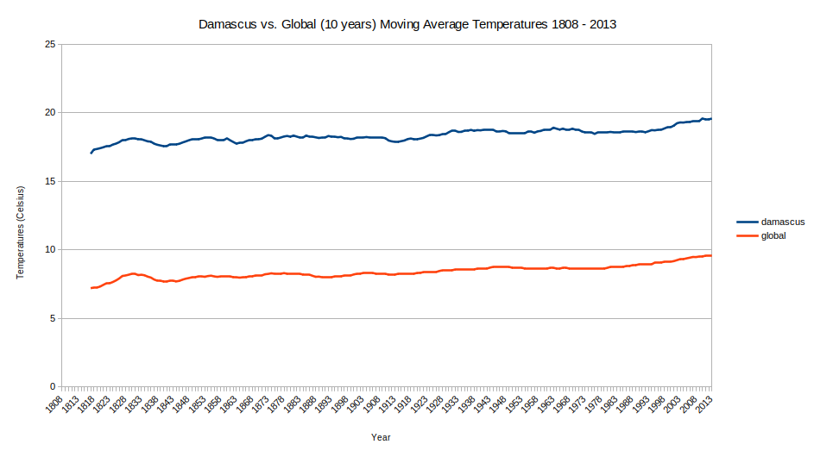
Chart 1: Damascus vs. Global (10 years) Moving Average Temperatures 1808-2013

In addition to, a visualization between some arabic cities were plotted, in order to make some insights between these cities. Some cities had missing data and some consideration were taken to make every country line starts in the correct year.

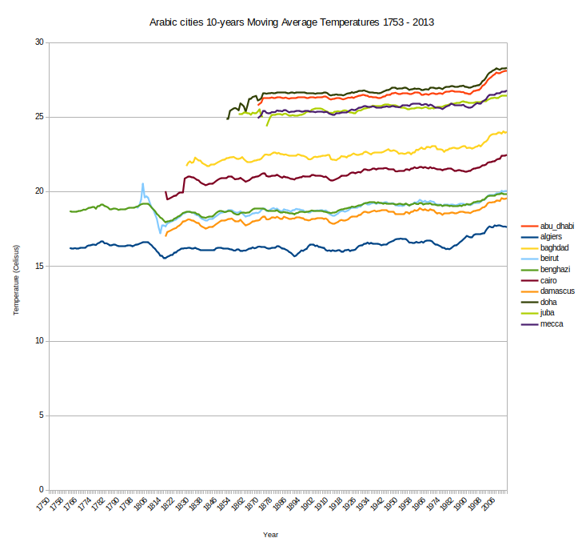
Chart 2: Comparison in local temperature between Arabic cities.

Observations
First: The Correlation Coefficient (ρ)
The correlation coefficient (ρ) is used to measured the linear correlation between years and temperature, in order to find if there is relation between them. By using LibreOffice Calc “CORREL” function to measure ρ, the measured value was equal to ρ = 0.881; Which indicates a high positive correlation (Direct proportionality) between years and temperature. we can explain this direct proportionality between them as a result from global warming.
Second: Local temperature compared to Global temperature
Comparing the local temperature with the global temperature for Damascus city using chart 1, we can observe that Damascus city have been always hotter than the global average by approximately 10°, as Damascus city is near the Equator.
Third: Comparing Arabic and Middle East cities average temperature
Observing chart 2, we can conclude that cities nearer to the Equator are hotter with temperatures higher than 25°, such as; Abu-Dhabi, and Mecca. Cities that are located in deserts also have temperature higher than 25°, such as; Juba, and Benghazi. While cities near the ocean and far from the Equator (compared to the rest) are the colder with temperatures approximately equal to 17 , such as; Algiers.
Fourth: Overall Trend
While observing the overall trend, the world average temperature had a peak in years range of 1820-1840, and followed by a constant temperature until 1980 , after that the world’s temperature started to increase but with a low rate of change.

